Table of Contents

1. Rationale 2
2. Algorithm 5
3. Pseudocode 7
4. Flowcharts 10
5. Functional Modules 13
6. Expected Outputs 14
8. GitHub Evidence 15
Conclusion 16
References 17

1. Rationale

1.1 Problem Description
In many schools in Sierra Leone, attendance is recorded in a paper register and is rarely analysed. A student can miss many days before any teacher or head teacher notices a pattern. By then the child may be far behind in lessons and may already be close to leaving school. Teachers have large classes and little time, so students who are slowly dropping out are easy to overlook.
Who is affected: students (especially girls, children from poor households and children in remote villages), parents and guardians, teachers and head teachers, and education officers who need accurate attendance information.
Why the problem exists:
- poverty and the need for children to work or help at home
- distance from school and poor roads
- early pregnancy and early marriage
- paper registers that are slow to add up and easy to make mistakes in
(5) no simple rule that tells a teacher when a student is “at risk” and needs a visit or a conversation.

1.2 Background
Education is a national priority in Sierra Leone, and the government’s Free Quality School Education programme has helped bring more children into classrooms. Getting children to enrol is only the first step; keeping them in school until they finish is just as important. Irregular attendance is one of the earliest and clearest warning signs of dropout. A simple, rule based system that calculates each student’s attendance percentage and flags those who are slipping can help teachers act early, before a student is lost. The design is deliberately light so that it could run offline on a basic computer or phone in a school with unreliable electricity and internet.

1.3 Proposed Solution
The proposed solution is a logical design for a School Attendance and Dropout Alert System. The teacher enters the number of school days so far and the number of students. For each student, the teacher enters the student’s name, the days present and the number of days missed in a row. The system validates the numbers, calculates the attendance percentage, and classifies the student as Good (80% or more), At Risk (60% to 79%) or Critical (below 60%). A student is also referred to a counsellor if classified Critical or if absent five or more days in a row. At the end, the system shows a class summary. This assignment presents the design only (algorithm, pseudocode, flowcharts and modules), not source code.

1.4 Computational Thinking Process
Technique | Application in this project
Decomposition | The system is split into modules: processStudent, calculateAttendancePercent, checkAttendanceStatus, needsReferral and displaySummary.
Pattern recognition | Every student goes through the same pattern: enter data, validate, calculate percentage, classify, decide on referral. A loop repeats this for each student.
Abstraction | Details such as timetables, subjects and parent contacts are ignored. Only the data needed to judge attendance is kept.
Algorithm design | Clear steps using sequence, selection (IF) and repetition (FOR, WHILE) were written, then converted to pseudocode and flowcharts.

1.5 Algorithm Design Approach
A top down approach was used. The main program collects the class details and then uses a counted loop to process each student. Each student is handled by one function, which in turn calls smaller functions for the percentage, the status and the referral decision. Input validation loops reject impossible values (for example, more days present than total school days) so that wrong data cannot produce wrong alerts.

1.6 SDG Alignment
Primary: SDG 4 Quality Education. The system supports the goal of inclusive and equitable education by helping schools keep children learning and finishing school (target 4.1).
Secondary: SDG 5 Gender Equality (girls are often the first to drop out, and early warning helps protect them) and SDG 10 Reduced Inequalities (children from poor and remote communities receive the same early support as others).

1.7 Open Source Justification
- Why open source: most schools cannot pay for licences; teachers and officials can read and trust the rules; and no company controls the system.
- Benefits for Sierra Leone: free use in every district, local customisation (language, thresholds, school calendar), skills for local students and developers, and low long term cost.
- Potential community contributions: teachers can suggest better thresholds, students can translate the interface or test it, developers can add SMS alerts or reports, and NGOs or the Ministry can contribute training material.

1.8 Digital Public Goods Justification
A Digital Public Good (DPG) is open source software, open data or open content that follows privacy and other laws and best practices, does no harm and helps attain the SDGs. This system could qualify by being released under an open licence (for example MIT), using open data formats so attendance data can be shared with national education systems, storing only the minimum student information to protect privacy, and being fully documented so any school or NGO can adopt it. It promotes accessibility (works offline on low-cost devices), openness (public code and rules) and public benefit (free for every school).

1.9 Sierra Leone Community Impact
- Problem solved: late discovery of students who are drifting away from school.
- Expected impact: teachers see at-risk students early; counsellors and head teachers can visit families sooner; attendance records become accurate and quick to summarise.
- Beneficiaries: students and families, teachers, head teachers, school management committees and district education officers.
- Long-term sustainability: no licence cost, runs on low cost hardware, maintained by the community through GitHub, and easy to teach in teacher training colleges.

2. Algorithm

2.1 Input, Processing and Output
Stage | Description
Input | Total school days; number of students; for each student: name, days present, consecutive days absent.
Processing | Validate inputs; calculate attendance percentage; compare with thresholds; apply Boolean rule for referral; update class counters.
Output | Each student’s percentage, status and referral decision; error messages; class summary.

2.2 Variables, Constants and Data Types
Name | Data type | Purpose
GOOD LIMIT = 80 | Real (constant) | Minimum percentage for “Good”
RISK LIMIT = 60 | Real (constant) | Minimum percentage for “At Risk”
ABSENCE LIMIT = 5 | Integer (constant) | Consecutive absences that trigger referral
MAX STUDENTS = 60 | Integer (constant) | Largest class size accepted
totalDays, numStudents | Integer | School days so far; number of students
name | String | Student name
daysPresent, consecutiveAbsent | Integer | Attendance data for one student
percent | Real | Attendance percentage
status | String | “Good”, “At Risk” or “Critical”
referral | Boolean | TRUE if the student needs a counsellor
goodCount, riskCount, criticalCount, i | Integer | Class totals and loop counter

2.3 Step-by-Step Algorithm
- Start the program and define the constants.
- Set goodCount, riskCount and criticalCount to 0.
- Ask for totalDays. Repeat until totalDays is greater than 0.
- Ask for numStudents. Repeat until it is between 1 and MAX_STUDENTS.
- Set i = 1.
- While i is less than or equal to numStudents, call processStudent(totalDays).
- In processStudent: read the name; read daysPresent until it is between 0 and totalDays; read consecutiveAbsent until it is between 0 and totalDays.
- Calculate percent = (daysPresent ÷ totalDays) × 100.
- Call checkAttendanceStatus(percent): if percent ≥ 80 return “Good”; else if percent ≥ 60 return “At Risk”; else return “Critical”.
- Call needsReferral(status, consecutiveAbsent): TRUE if status is “Critical” OR consecutiveAbsent ≥ 5.
- Display the name, percentage and status. If referral is TRUE, display “Refer to counsellor”; otherwise “No referral needed”.
- Return the status to Main. Main increases the matching counter and sets i = i + 1.
- When all students are processed, display the class summary and stop.

3. Pseudocode

3.1 Main Program
START Main
CONSTANT GOOD_LIMIT = 80, RISK_LIMIT = 60
CONSTANT ABSENCE_LIMIT = 5, MAX_STUDENTS = 60
SET goodCount = 0, riskCount = 0, criticalCount = 0
REPEAT
INPUT totalDays
IF totalDays <= 0 THEN OUTPUT "Total days must be above 0"
UNTIL totalDays > 0
REPEAT
INPUT numStudents
IF numStudents < 1 OR numStudents > MAX_STUDENTS THEN
OUTPUT "Enter a number from 1 to", MAX_STUDENTS
END IF
UNTIL numStudents >= 1 AND numStudents <= MAX_STUDENTS
FOR i = 1 TO numStudents DO
SET status = processStudent(totalDays)
IF status = "Good" THEN
goodCount = goodCount + 1
ELSE IF status = "At Risk" THEN
riskCount = riskCount + 1
ELSE
criticalCount = criticalCount + 1
END IF
END FOR
CALL displaySummary(goodCount, riskCount, criticalCount)
END Main

3.2 Function: processStudent
FUNCTION processStudent(totalDays)
INPUT name
REPEAT
INPUT daysPresent
IF daysPresent < 0 OR daysPresent > totalDays THEN
OUTPUT "Invalid days present. Try again."
END IF
UNTIL daysPresent >= 0 AND daysPresent <= totalDays
REPEAT
INPUT consecutiveAbsent
IF consecutiveAbsent < 0 OR consecutiveAbsent > totalDays THEN
OUTPUT "Invalid number. Try again."
END IF
UNTIL consecutiveAbsent >= 0 AND consecutiveAbsent <= totalDays
SET percent = calculateAttendancePercent(daysPresent, totalDays)
SET status = checkAttendanceStatus(percent)
SET referral = needsReferral(status, consecutiveAbsent)
OUTPUT name, percent, status
IF referral = TRUE THEN
OUTPUT "Refer to counsellor"
ELSE
OUTPUT "No referral needed"
END IF
RETURN status
END FUNCTION

3.3 Functions: calculateAttendancePercent, checkAttendanceStatus, needsReferral
FUNCTION calculateAttendancePercent(daysPresent, totalDays)
RETURN (daysPresent / totalDays) * 100
END FUNCTION

FUNCTION checkAttendanceStatus(percent)
IF percent >= GOOD_LIMIT THEN
RETURN "Good"
ELSE IF percent >= RISK_LIMIT THEN
RETURN "At Risk"
ELSE
RETURN "Critical"
END IF
END FUNCTION

FUNCTION needsReferral(status, consecutiveAbsent)
RETURN (status = "Critical") OR (consecutiveAbsent >= ABSENCE_LIMIT)
END FUNCTION

3.4 Function: displaySummary
FUNCTION displaySummary(goodCount, riskCount, criticalCount)
SET total = goodCount + riskCount + criticalCount
OUTPUT "Students processed:", total
OUTPUT "Good:", goodCount, "At Risk:", riskCount, "Critical:", criticalCount
IF total > 0 THEN
OUTPUT "Share needing attention:", ((riskCount + criticalCount) / total) * 100, "%"
END IF
END FUNCTION

4. Flowcharts
Symbols: rounded rectangle = start/end; parallelogram = input/output; rectangle = process; diamond = decision; double-bordered rectangle = call to a function/module.

4.1 Main Program Flowchart
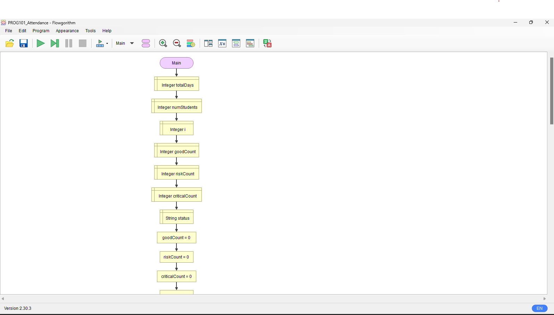

4.2 checkAttendanceStatus Flowchart
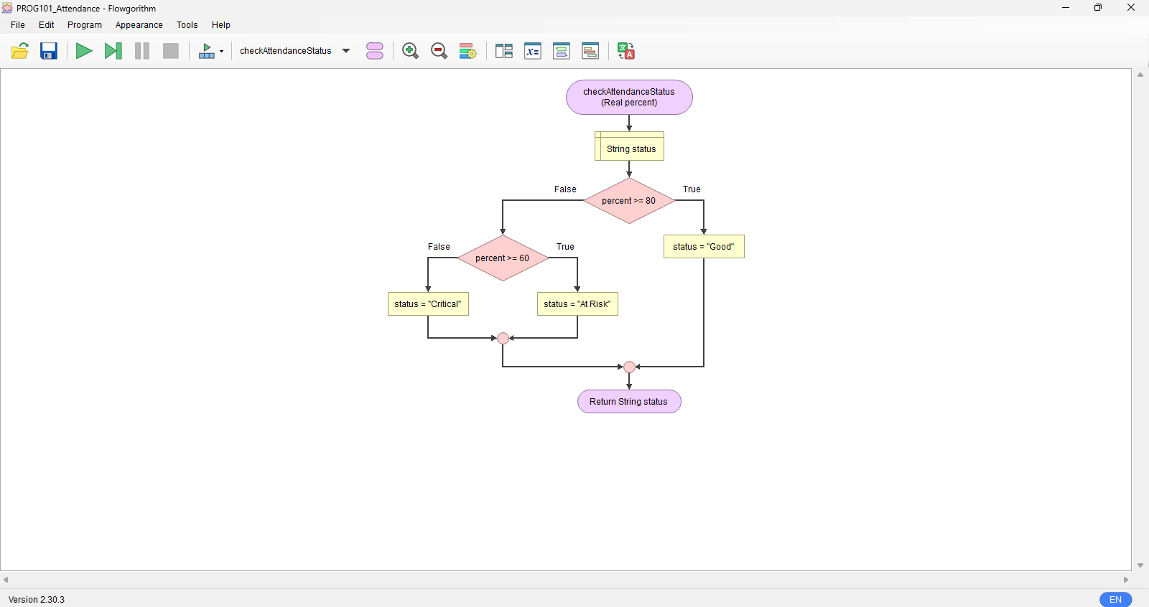

4.3 processStudent Flowchart
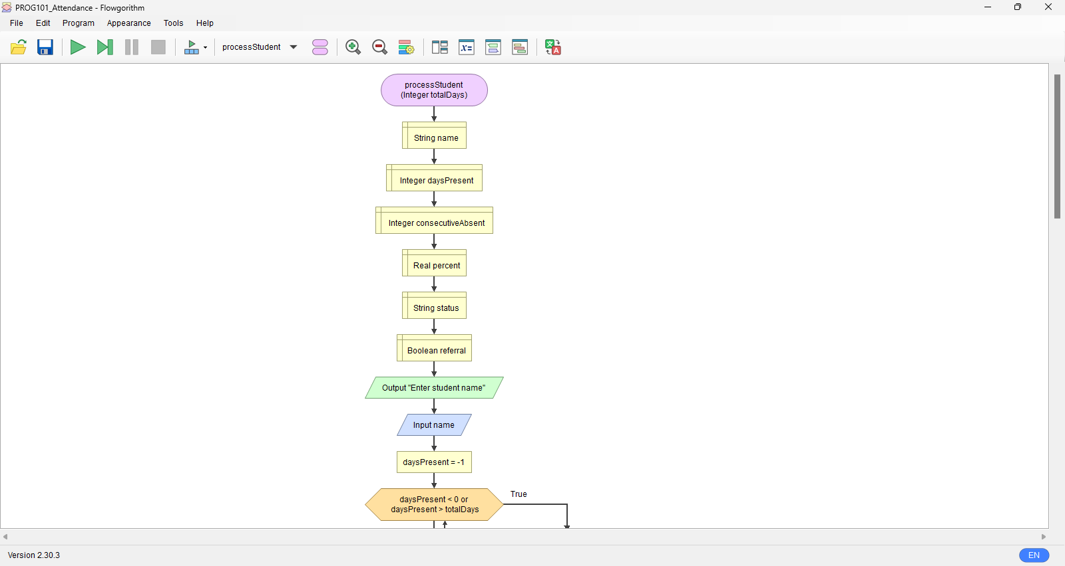
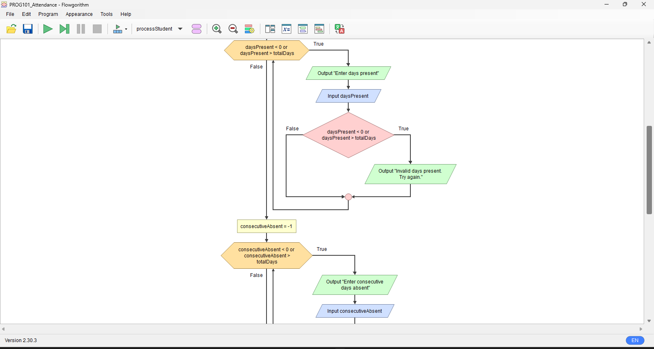
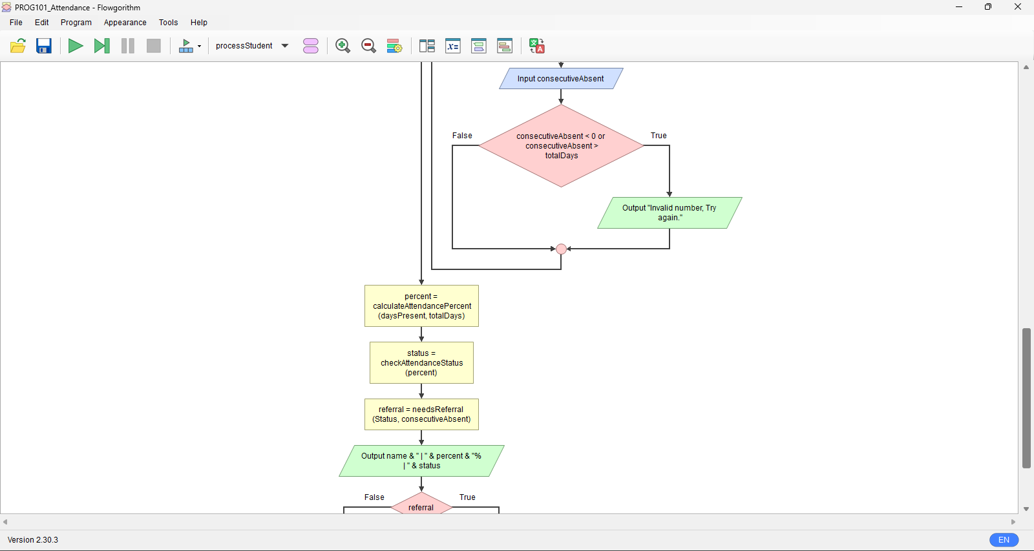
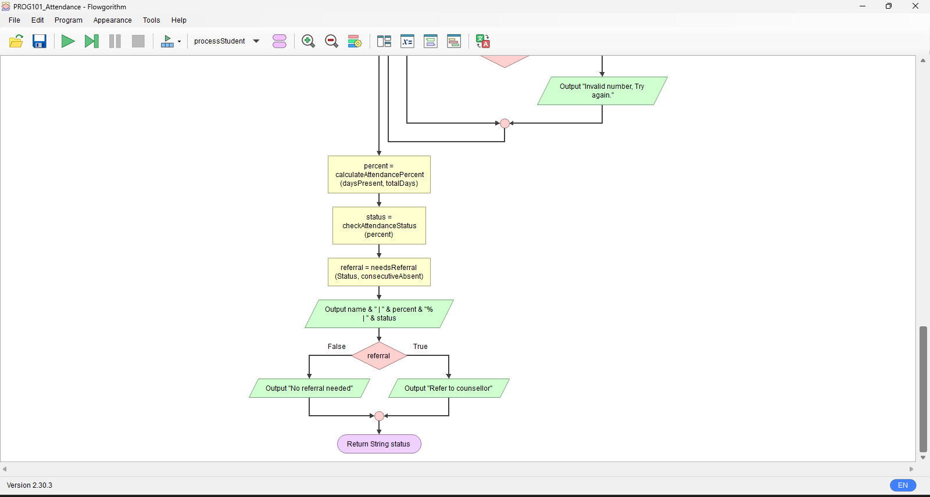

5. Functional Modules
Module | Purpose | Inputs | Outputs / Returns
processStudent() | Reads and validates one student’s data and shows the result | totalDays | status
calculateAttendancePercent() | Works out attendance percentage | daysPresent, totalDays | percent (Real)
checkAttendanceStatus() | Classifies the student using thresholds | percent | "Good", "At Risk" or "Critical"
needsReferral() | Boolean rule for counsellor referral | status, consecutiveAbsent | TRUE or FALSE
displaySummary() | Shows class totals | Three counters | Summary text

5.1 Logic Concepts Demonstrated
- Decision structures: IF / ELSE IF / ELSE for status and referral messages.
- Repetition structures: FOR loop through students; REPEAT…UNTIL loops for validation.
- Boolean logic: OR and comparison operators in needsReferral and validation checks.
- Functions and modules: five reusable functions, each doing one job.
- Problem decomposition: one large problem split into small, testable parts.

6. Expected Outputs

6.1 Test Scenarios (Total school days = 100)
# | Student | Days present | Consecutive absent | Percent | Status | Referral
1 | Aminata | 92 | 0 | 92% | Good | No
2 | Sorie | 70 | 2 | 70% | At Risk | No
3 | Fatu | 45 | 3 | 45% | Critical | Yes (Critical)
4 | Mohamed | 85 | 6 | 85% | Good | Yes (6 absent in a row)

6.2 Sample Run
Enter total school days: 100
Enter number of students: 4
Name: Aminata Days present: 92 Consecutive absent: 0
>> Aminata | 92% | Good | No referral needed
Name: Sorie Days present: 70 Consecutive absent: 2
>> Sorie | 70% | At Risk | No referral needed
Name: Fatu Days present: 45 Consecutive absent: 3
>> Fatu | 45% | Critical | Refer to counsellor
Name: Mohamed Days present: 85 Consecutive absent: 6
>> Mohamed | 85% | Good | Refer to counsellor

--- CLASS SUMMARY ---
Students processed: 4
Good: 2 At Risk: 1 Critical: 1
Share needing attention: 50 %

6.3 Validation and Error Scenarios
Scenario | Input | Expected output
Zero school days | totalDays = 0 | "Total days must be above 0" and asks again
Class too large | numStudents = 80 | "Enter a number from 1 to 60" and asks again
More days present than school days | daysPresent = 120 (total 100) | "Invalid days present. Try again."
Negative absence | consecutiveAbsent = -2 | "Invalid number. Try again."

8. GitHub Evidence
Insert the evidence below before printing. Replace each placeholder with a real screenshot or text.
Item | Evidence
GitHub Repository | [Paste screenshot of the repository home page]
Repository URL | https://github.com/[your-username]/PROG101_Assignment1_[StudentName]_[StudentID]
Git Commit History | [Paste screenshot of the Commits page or output of: git log --oneline]
README.md | [Paste screenshot of the rendered README.md]
Repository Screenshot | [Paste screenshot showing Report, Flowcharts, Pseudocode and README.md files]

Conclusion
In many schools in Sierra Leone, attendance is written in a register and then forgotten. A child can slowly stop coming to school, and nobody notices until it is too late. This project set out to change that with a simple and logical design.
The system takes a few numbers for each student, works out an attendance percentage, and labels the student as Good, At Risk or Critical. It also checks for long runs of absence, because a student who has missed five days in a row needs attention even if the overall percentage looks fine. Breaking the problem into small modules made it much easier to understand. Each part, from calculating the percentage to deciding on a referral, could be planned, drawn and tested on its own.
Building the flowcharts in Flowgorithm helped me see how decisions, loops and functions really work together. The project supports SDG 4, Quality Education, because it helps schools keep children learning. I believe it should be open source so any school in any district can use it free of charge, adapt it, and improve it together. In the future it could grow into a full application that works offline and sends SMS alerts to parents. Even as a design alone, it shows how clear thinking can help solve real problems in our communities.

References
- United Nations. Sustainable Development Goals, Goal 4: Quality Education. https://sdgs.un.org/goals/goal4
- UNESCO. Education and school dropout resources. https://www.unesco.org
- Ministry of Basic and Senior Secondary Education, Sierra Leone. https://mbsse.gov.sl
- Digital Public Goods Alliance. The DPG Standard. https://digitalpublicgoods.net/standard/
- Open Source Initiative. The Open Source Definition. https://opensource.org/osd
- Flowgorithm. Flowchart programming language. http://www.flowgorithm.org
- Limkokwing University of Creative Technology, Sierra Leone. PROG101 Assignment Brief, September 2026.

